#### Discharge characteristics of Li ion Battery pack with 4S 40A BMS

This experiment is conducted to obtain the discharge characteristics of the Li-ion battery pack and plot the characteristics against various load current.

Components used:-

Li-ion battery pack( 4S 4P), 4s 40A BMS, current sensor (INA 169) , multimeter , BLDC motor with ESC,

RC transmitter,connecting wires.

Experimental setup:-

The BLDC motor connected with a propeller acts as a load. The motor is connected to an ESC which takes the PWM signals from the receiver to control the speed of the motor. By controlling the throttle , the speed of the motor is varied and hence the load current also varies.

Current sensor is connected between the battery pack and the load, the three leads of the sensor are connected to an arduino board which continuously samples the adc value from the input pins.These adc values are converted to the measured current values by dividing the reading with the sensitivity of the current sensor. A multimeter is also connected in series to measure the current readings.

Table 1.1 :

|  |  |  |
| --- | --- | --- |
| Battery voltage :15.83 V | | |
| Sensitivity considered: 73.2mv/A | | |
| S no | Voltage Measured (V) | Multimeter reading (A) | | Measured Value(A) | Error | Error % |
|  |  |  | |  |  |  |
| 1 | 15.73 | 0.05 | | 0.00 | -0.05 | 100% |
| 2 | 15.12 | 0.60 | | 0.47 | -0.13 | 22% |
| 3 | 14.58 | 1.02 | | 1.00 | -0.02 | 2% |
| 4 | 14.04 | 1.52 | | 1.60 | 0.08 | 5% |
| 5 | 13.58 | 1.99 | | 2.20 | 0.21 | 11% |
| 6 | 13.05 | 2.48 | | 2.87 | 0.39 | 16% |
| 7 | 12.51 | 2.98 | | 3.47 | 0.49 | 16% |
|  |  |  | |  |  |  |

Observations:-

* The above readings were taken with interval of 0.5A of current, further as the current was increased the voltage level dropped below the overdischarge voltage level which is around 11.2V and the load was prevented to draw further current.
* It can be inferred that when the voltage goes below the set point, the BMS cuts off the supply to the load and waits for the voltage to rise above the set discharge voltage level.
* The above readings were measured through a 10-bit ADC of arduino, hence the resolution is very less. It is advisable to use a resolution of 12-bit or more for better accuracy.

Observations:-

* While the limitation in current drawn from the battery can be attributed to the undervoltage , the same setup when measured current without using the multimeter, the current drawn exceeded to a maximum of 25A (tentative since measured through sensor) the voltage was about 11.8V
* It can be inferred that either the balance voltage levels must be below the overdischarge voltage level or Li ion battery has reached the max discharge current limits.
* Li-ion can be discharged to 1.5C ie., 3.25*1.5=4.875A /cell since 4P is used max discharge can be 4.875*4=19.5A continuous current. Further increase in current will result in drastically reduced voltage levels.

Detailed tabulation of readings are available in excel document :mod_load_test 1.1

**Comparison of Li-po with Li-ion**

Li-po battery (3S 3000mah 30C) was able to meet the demand of the load when increased from no load to full load.

The characteristics was a smooth curve on increasing and decreasing the load.

Li-ion on the other hand was unable to meet the peak demands due to limitations in the internal resistance of the battery which increases the resistive drop on increased current and thereby decreasing the cell voltage below the threshold limit set by the BMS and hence spiking of current occurs.

Detailed tabulation of readings are available in excel document :mod_load_test 2.1

**Capacity test: Discharge on constant load**

The battery discharge was tested against a constant load for about 4hrs with a constant current load of 0.6A (discharged using a discharger unit -limitation in max current drawn).

The voltage dropped steadily at a constant rate.

Calculation for capacity:-

Initial battery voltage: 15.495V …(C)

The slope of the line was estimated to be around -0.062mv /s …(M)

Cut-off voltage considered: 12v (assuming voltage drop is linear till cut off voltage) …(Y)

Equation of slope of the line

Y=MX+C

=> 12 = -0.000062 *X +15.495

=> X = 56181 s

=> X = 15.6 hrs …(1)

Since the constant current=0.62A …(2)

Approximate capacity discharged = (1) * (2)

= 15.6*0.62 = 9.675Ah

The same curve when extrapolated to initial voltage of 16.8V will further add a capacity of 3.613Ah

Adding to a total of 13.3Ah which is considerable amount when compared with the theoretical value of 13.7Ah.

Detailed tabulation of readings are available in excel document :mod_load_test 3.1

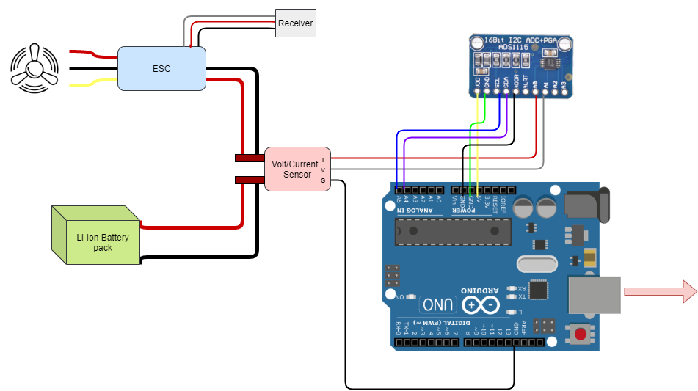

Fig 1.1 Circuit diagram representing the components connected to the ADS1115 and Arduino Uno